**LAB 14: (ASSIGNMENT # 05)**

**SUBMITTED BY: NOOR-UL-AIN(BCS223020)**

**PRACTICE TASK 1:**

**CODE:**

#include <iostream>

using namespace std;

class Square; //declaration

class Circle

{

private:

double radius;

public:

Circle(double r)

{

radius = r;

}

friend double cal_para(const Square& sq);

friend class area;

};

class Square

{

private:

double length;

public:

Square(double len)

{

length = len;

}

friend double cal_para(const Square& sq);

friend class area;

};

double cal_para(const Square& sq)

{

return 4 * sq.length;

}

class area

{

public:

static double cal_circle_ar(const Circle& c)

{

return 3.141592653589793 * c.radius * c.radius;

}

static double cal_square_ar(const Square& s)

{

return s.length * s.length;

}

};

int main()

{

Circle circle(7.4);

Square square(2.9);

double sqr_para = cal_para(square);

cout << " Perimeter of a square: " << sqr_para << endl;

double circle_area = area::cal_circle_ar(circle);

cout << " Area of a circle: " << circle_area << endl;

double square_area = area::cal_square_ar(square);

cout << " Area of a square: " << square_area << endl;

return 0;

}

**OUTPUT:**

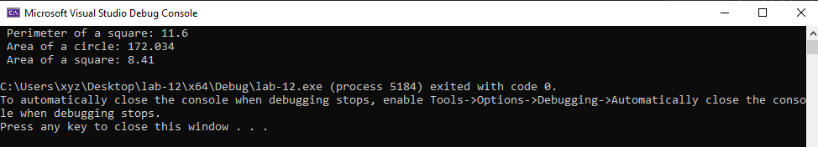

**PRACTICE TASK 2:**

**CODE:**

#include <iostream>

using namespace std;

class Calculation; // declaration

class Data

{

private:

float a;

float b;

public:

Data(float x, float y)

{

a = x;

b = y;

}

friend void display(const Data& d);

friend class Calculation;

};

void display(const Data& d)

{

cout << " Data member a = " << d.a << endl;

cout << " Data member b = " << d.b << endl;

}

class Calculation

{

public:

static float sum_sqr(const Data& data)

{

return data.a * data.a + data.b * data.b + 2 * data.a * data.b;

}

static float diff_sqr(const Data& data) {

return data.a * data.a + data.b * data.b - 2 * data.a * data.b;

}

};

int main()

{

Data obj(2.5,5.6);

display(obj);

cout << "Square of Sums= " << Calculation::sum_sqr(obj) << endl;

cout << "Square of Difference= " << Calculation::diff_sqr(obj) << endl;

return 0;

}

**OUTPUT:**

